**ME 111 Engineering Drawing**

**Lab 10 Isometric views Thursday Batch**

**Q. 1 Following figure shows orthographic views of an object. Draw its ISOMETRIC VIEW. [20 marks]**

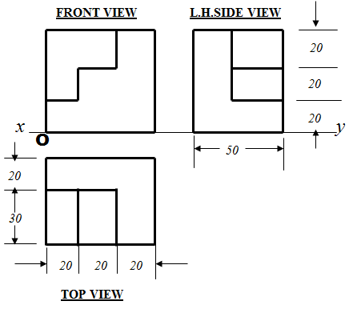

**Answer {VIEW to be drawn with true dimensions.}**

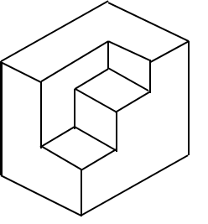

**Q.2 Following figure shows orthographic views of an object. Draw its ISOMETRIC VIEW. [30 marks]**

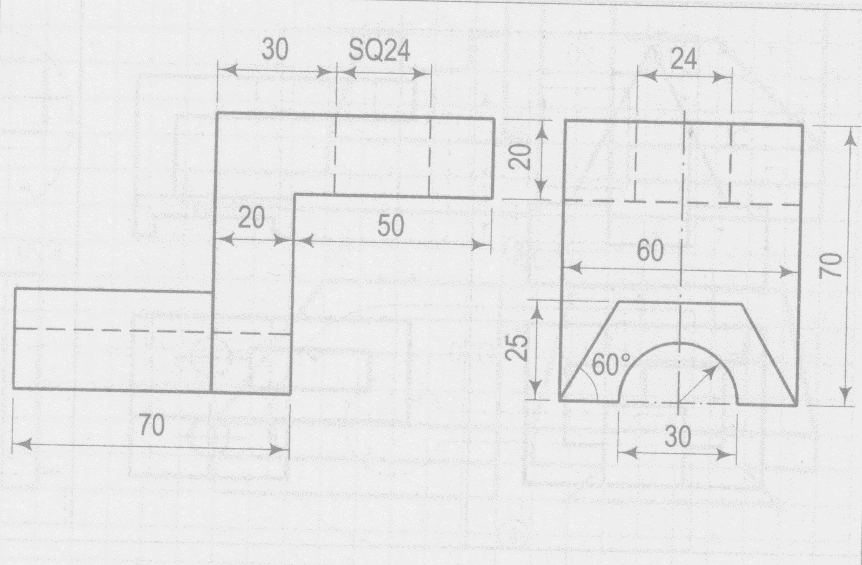

**Answer {VIEW to be drawn with true dimensions.}**

